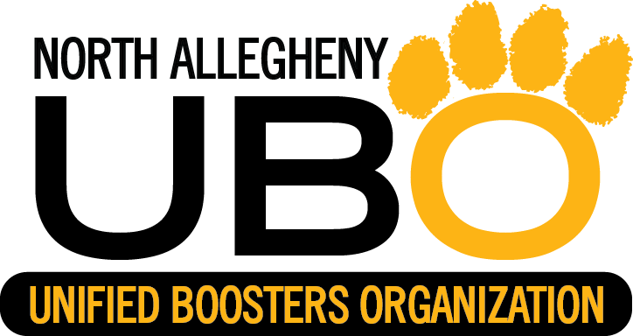

**PROFIT WILL GO TO NA TOYS FOR TIGERS PROGRAM**

**CHECKS MADE PAYABLE TO NAUBO**

**SWEATSHIRT T-SHIRT**

**$30.00 (S, M, L, XL) $10.00 (S, M, L, XL)**

**$32.00 (XXL, XXXL) $12.00 (XXL, XXXL)**