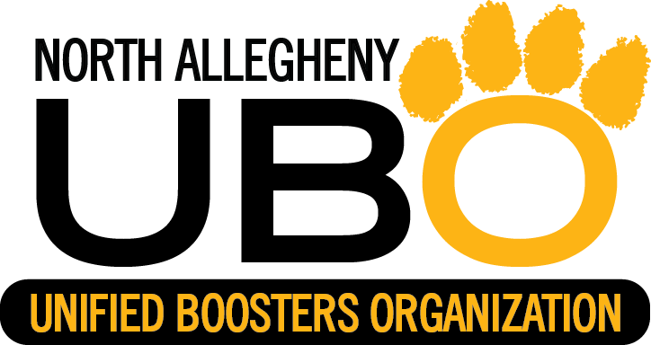

**PROFIT WILL GO TO NA TOYS FOR TIGERS PROGRAM**

**CHECKS MADE PAYABLE TO NAUBO**

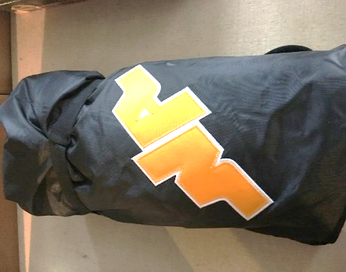  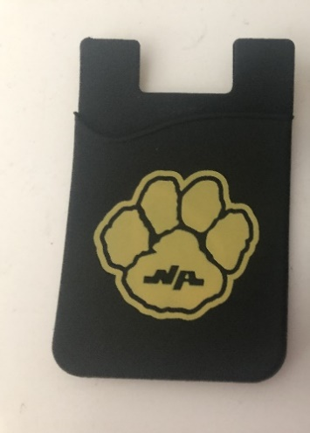

**NA STADIUM BLANKET NA HAT CELL PHONE WALLET**

**$40.00 $30.00 $3.00**

**ELECTROSTATIC STICKER NORTH ALLEGHENY SUNGLASSES CROC CHARMS**

**$2.00 $5.00 $5.00**