North Allegheny Unified Booster Organization
April 25, 2025 Meeting Minutes

Board Members Present: Georgiana Thomas (President/Scholar Athlete Coordinator/Website Chair) and Patti McClure (Vice President)

NA UBO Sponsor: Bob Bozzuto (Athletic Director/Bocce)
Chairperson(s) Present: Valerie Scolieri (Tiger Items Sales/ T4T Gift Wrapping) and Julie Dubis (IMS Scholar Athlete)

Representative Present: Karen Plotsko (Softball-Fast pitch), Sha Luangkesorn (Rowing), Paula Dworek (Baseball), Laurie Abel (Cross Country and Track & Field), Valerie Scolieri (Boys Basketball), Meighan Nalducci (Field Hockey and Boys Lacrosse), Nicole Gross (Field Hockey and Flag Football), Swathi Dopathi (Boys Tennis), Brenna Sisinni (Girls Lacrosse), Kelly Spino (Water Polo) and Todd Harbaugh (Swimming and Diving)

Welcome & Introductions

Approval of February 2025 Minutes: No recommended changes proposed to the Minutes. Motion was passed to approve the meeting minutes. The minutes were approved.

Treasurer Report: The report was reviewed as of April 25, 2025 there was a beginning balance of $13,184.69, UBO deposited $106, expenses $3,131.75 ending balance is $10,158.94. Motion was passed to approve the report. The report was approved.

Kennywood: Tickets sales August 16 and 17Discount ticket - $40 one day ticket, can only be used August 17. Will be sending out Kennywood flyer. Please look forward to your groups. Volunteers to sell Tickets – passed around sign up sheet.

NA Community Day – August 16, 2025. 5k run and 1 mile run. Doing NA baskets, if you have any NA items you sold could you donate for the baskets. Bob will be sending out information.

Toys for Tigers (T4T): UBO will be doing a Wendell August ornament that will be for sale.

Membership: Passed Roster around and asked everyone to let us know if they would be returning or if they knew the new replacement. Asked them to add phone in we need to text them.

Scholar Athlete: Informed the Spring sports that their awards were available to pick up and were in the ticket booth room.

UBO Awards: Thank the committee. Shared dates for next year. See last paragraph.

TEAM Reports:

Baseball

1. What are your dues?
• Freshman - $200
• JV/Varsity - $250
2. Does your booster organization include middle school parents? Yes. If yes, what are the MS
dues? $150
3. If family has more than 1 child participating, do you offer discounts? If so, explain. Yes, we have a
family cap of $250.
4. Name several fundraisers your group participates in during the year.
• YETI Raffle Fundraiser
• DeeJays Fundraiser
• NA Lanyard Fundraiser
• Winter/Holiday & Spring Apparel Sales
• Yard Signs, Magnets, and Vinyl Car Stickers
• Fat Heads
• TIGERFEST Fundraisers: Hats, blankets, umbrellas, apparel, and lanyards
5. Is your team a 501C3 organization? Yes
6. Does your team have “volunteer days”? If yes, explain. Yes.
• Annual Apraxia Walk: Supporting Coach Phil Coffin’s daughter by accepting cash
donations in her honor to raise awareness and funds for Apraxia.
• Bubba’s Backpack Brigade: Collecting new and gently used backpacks and school
supplies for underprivileged children in the Pittsburgh area.
• Toys for Tigers: Partnering with NASD to shop for four underprivileged children during the
holiday season.

Rowing
What are your dues?
HS Fall 675 / Winter 275 / Spring 625
Dev Team Fall 325 / Winter 225 / Spring 315
Does your booster organization include middle school parents? Yes. Dues listed above.
If family has more than 1 child participating, do you offer discounts? No.
Name several fundraisers your group participates in during the year?
Cash Bash
Zroni Rolls
Jenny Lee bread
Aramark Fundraising
Raise Right goes on year round
Is your team a 501C3 organization? YES.
Does your team have “volunteer days”? If yes, explain. Many volunteering opportunities are available to parents and athletes. See following list for examples.
For Parents and Athletes
Erg in Burgh
Head of the Ohio Open House
Chili Cook-off and Holiday Party
Annual Cash Bash
Michigan Races
Pgh Sprint
End of the Year banquet
Pasta party
For athletes:
Summer Rowing Camps
Alumni Races

Softball - Fast Pitch
North Allegheny Fast Pitch Softball – Spring Report 2025
Season Summary – Currently 8-5, 3 more section games left. 3rd place in Section 6A. All new coaching staff this year, 7 senior starters graduated from last year, only 2 seniors this year. Should make playoffs.
1 and 2) Booster dues are as follows:
Varsity and JV: $200, $100 Concession Deposit (returned if you work 2 games)
Middle School: $75, $50 Concession Deposit (returned if you work 1 game)
3) Yes to family discounts ~ if 2 JV/Varsity, $100 discount in total. If 1 JV/Varsity and 1 MS, $50 discount in total.
4) The team does Spring Training in FL every other year, this was a FL year. We tried something new, Blast Fundraising Video. Earned over $8,700 in about 5 weeks, less 18% service fee to Blast, we were able to reduce each girl’s travel cost by $325.
Other fundraising this year – CFA Nugget Trays, Spirit Wear Sale. Other than these (and booster fees), the rest of our funding comes from our Concession Stand earnings.
5) Yes, we are a 501(c)3 Organization
6) No, we don’t have Volunteer days.

Track & Field
TRACK & FIELD - BOYS & GIRLS (Laurie Abel)

1.) What are your dues? High School is $150 for the 1st athlete/$60 for each additional athlete in the same family. There are provisions for families who may be experiencing financial hardship.

2.) Does your booster organization include middle school parents? If yes, what are the MS dues? Yes. Middle School is $30 for the 1st athlete/$20 for each additional athlete in the same family. There are provisions for families who may be experiencing financial hardship.

3.) If a family has more than 1 child participating, do you offer discounts? If so, explain. Yes - see above.

4.) Name several fundraisers your group participates in during the year? Spirit Wear (BSN), Moe's Meal Kits, Chipotle, yard signs, concessions

5.) Is your team a 501C3 organization? Yes

6.) Does your team have "volunteer days"? If yes, explain. NATF Camp for elementary students is usually the first full week of summer. High school athletes can volunteer to help out at this camp.

We donated $350 to Toys for Tigers this year.

Volleyball-Boys
- What are your dues? High School Dues are $250
- Does your booster organization include middle school parents? If yes, what are the MS dues? Yes, Middle School Dues are $60.
- If a family has more than 1 child participating, do you offer discounts? If so, explain. Not at this time, but we do encourage those to let us know if they are having difficulty letting us know and we can make arrangements.
- Name several fundraisers your group participates in during the year?
We have a raffle at the beginning of the season for 2 $500 prizes. We have small games of chance license for this raffle.
We host the N.A. Invitational tournament at the beginning of the season, and the concessions are a big source of income to fund our season. This year, due to increased expenses and needs, we tried additional fundraisers such as Dine and Donates with Chipotle, they did not generate large amounts but still helped.
We also tried selling ads in our tournament program which was a first time for us, and we can improve on that next year. Our season is very short and during spring when lots of other events are going on such as Weddings, Mother’s Day, Easter, Prom, Graduations, Communions, etc and are competing with a lot of different events and fundraisers. Always looking for ideas.
- Is your team a 501C3 organization? Yes. We are a 501c, we also have a PA Sales Tax Exemption. Note that PA requires
- Does your team have “volunteer days”? If yes, explain. No formal days.
Our last regularly scheduled section home Game is Tuesday 4/29 @ 7pm. We are currently second to Seneca who is 10-2 and we are 9-1. They are the only team that we lost to this season, and we are expecting it to be a thriller. We hope that the students and community turn out to support us and help bring some energy
Lacrosse-Girls

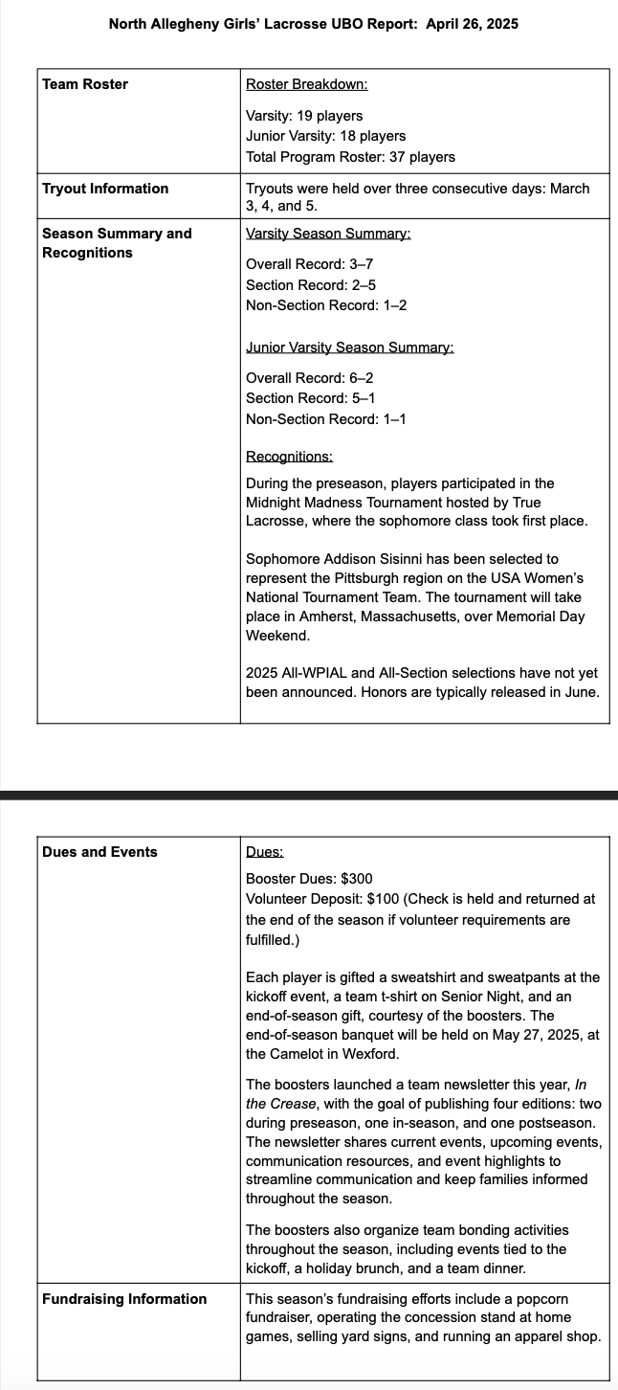

Tennis- Boys
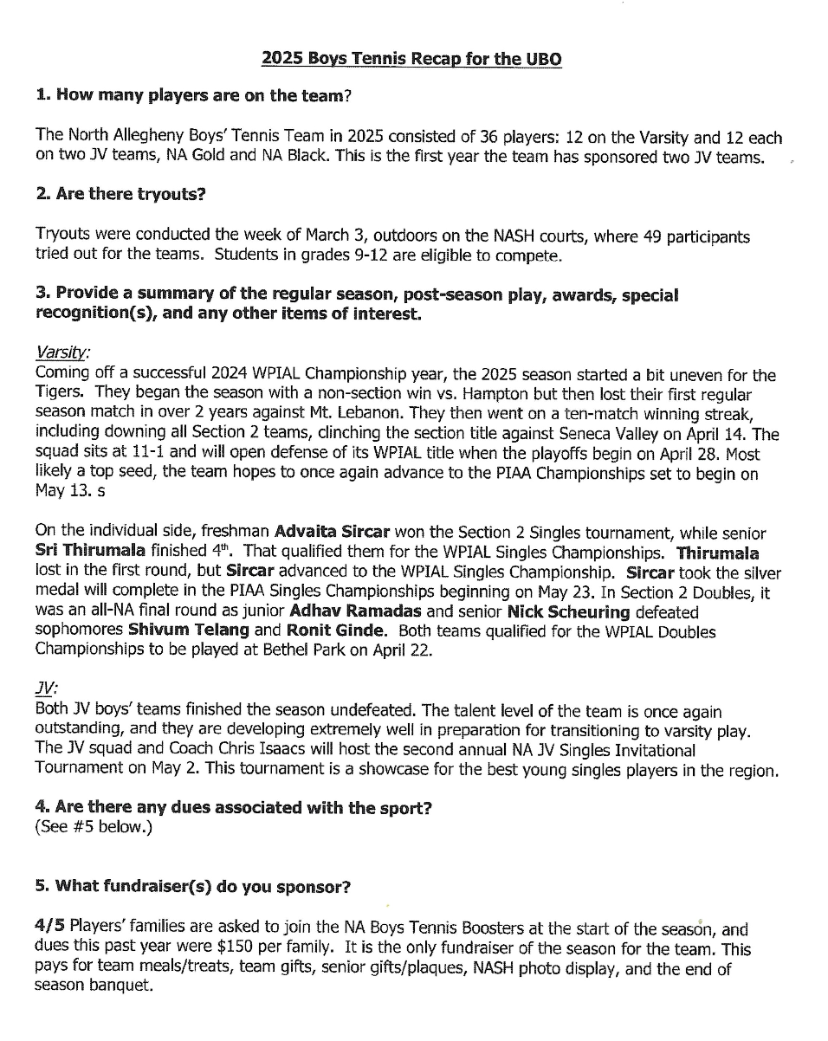

Flag Football-Girls

Lacrosse-Boys

Softball-Slow Pitch

Asked rep to send copy to Barb of their report to be include in the minutes.

- 2025-2026 UBO MEETING DATES
- September 10, 2025 @ 6:30 pm
- November 12, 2026 @ 6:30 pm
- February 11, 2026 @ 6:30 pm
- April 25. 2026 @ 9:00 am

- UBO Awards
- Application due Monday, March 30, 2026
- Interviews - Tuesday, April 13, 2026

Adjournment: Motion passed to adjourn the meeting

