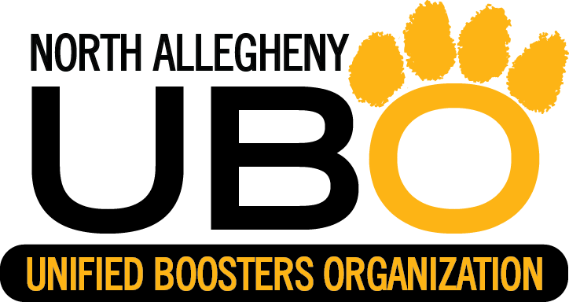
PROFIT WILL GO TO NA TOYS FOR TIGERS AND AWARD PROGRAMS
CHECKS MADE PAYABLE TO NAUBO

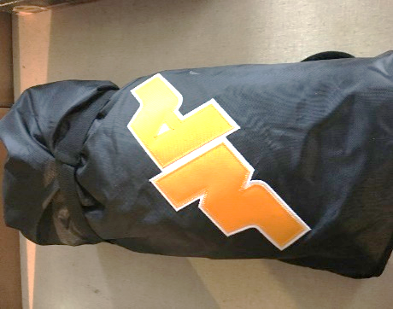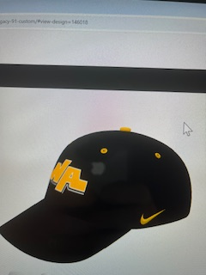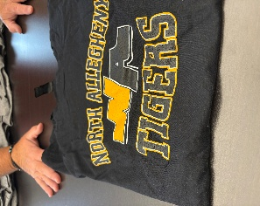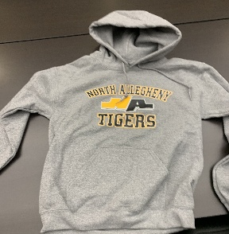

NA STADIUM BLANKET NA HATS T-SHIRTS HOODIES
$40.00 $20.00 Black, Gray Black, White, Gray
$15.00 $20.00
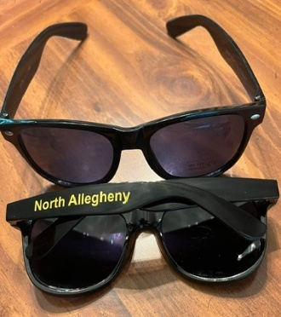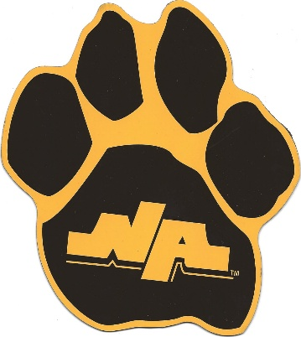
NA SUNGLASES ELECTROSTATIC STICKERS CAR MAGNETS
$5.00 $2.00 & $5.00 $3.00

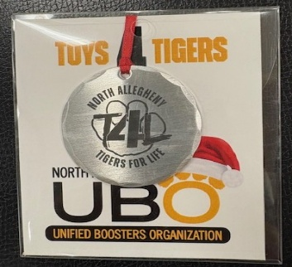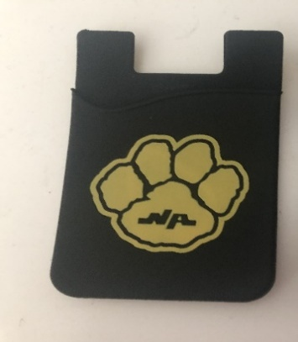
WENDELL AUGUST FORGE TIGER TOWEL CELL WALLET
CHRISTMAS ORNAMENT - $20.00 $5.00 $3.00

